**Table of Content:**

1. **Introduction– *1***
2. **Glossary– *2***
3. **User Requirements Definition– *3***
4. **System Architecture– *3***
5. **System Requirements Specification– *4***
6. **System Model– *5***
7. **System Evolution– *6***
8. **Appendices–*6***
9. **Index–*6-7***

**Project Name:** Match Mingle (Online Matrimony Website)

**1. Introduction**

Match Mingle Online Matrimony aims to revolutionize the matchmaking experience by providing a seamless, secure, and efficient platform for brides and grooms to find their ideal life partners. The platform will offer advanced matchmaking algorithms, user-friendly navigation, and privacy-focused communication tools to ensure a smooth and personalized experience for every user.

Our goal is to create a reliable and inclusive matchmaking solution that caters to diverse preferences while ensuring data security, user privacy, and a high success rate in partner connections. The platform will include essential features such as profile creation, compatibility-based matching, secure messaging, subscription plans, and an admin dashboard for efficient user management. With a strong focus on user satisfaction, security, and operational efficiency, the project aims to establish a leading online matrimony service within the given budget and timeline.

**1.1 Purpose**

The matrimony website aims to provide a secure, user-friendly platform for individuals to find compatible marriage partners based on preferences such as religion, caste, profession, and location. This SRS defines the functional and non-functional requirements to guide development.

**1.2 Scope**

The website will:Allow users to register, create profiles, and search for potential matches.Provide communication tools like messaging, interest requests for user interaction.Ensure privacy and security of user data.Support administrators in managing user accounts and content.Integrate with payment gateways for premium features.

**1.3 System Context**

The website operates as a web-based application accessible via browsers on desktops and mobile devices. It integrates with:External payment gateways like Bikash for premium subscriptions.Email and SMS services for notifications.Third-party APIs for identity verification .

**1.4 Business Objectives**

Facilitate meaningful connections for marriage seekers.Generate revenue through premium memberships and advertisements.Build a trusted platform with high user satisfaction and data security.

**2. Glossary**

| **Terms** | **Definition** |
| --- | --- |
| MatchMingle | The name of the matrimony platform, branded in the navbar and footer across all pages, aimed at connecting users for meaningful relationships. |
| Privacy Policy | A set of guidelines in privacy.php explaining data usage and content practices, organized in an accordion format like- "User-Centric Content," "Avoiding Complex Language". |
| Profile Verification | A service in services.php and a condition in terms.php involving ID and social media checks to ensure profile authenticity, linked to verification.php. |
| Subscription | A paid service outlined in subscription.php offering Basic, Premium, and Gold plans with varying features, linked to payment.php for processing. |
| Card | A UI component used in userhome.php, services.php, and subscription.php to display content (example- user profile details, service descriptions, or subscription plans) in a visually structured format with headers and bodies. |
| Premium Membership | A service in services.php and a subscription tier in subscription.php (2198.9 BDT/month) offering exclusive features like unlimited messaging, contact details, and priority matches. |
| bKash Number | A valid 11-digit Bangladeshi mobile number used for processing payments via the bKash mobile financial service. |
| Conversation | A series of messages exchanged between two users, displayed in chronological order with sender and receiver details. |
| Notification Badge | A visual indicator like - number in a red circle, showing the count of unread messages in the inbox. |
| Payment Request | A user-submitted request for subscription plan activation, including bKash number, transaction ID, plan type, and amount, pending admin approval. |
| Partner Preferences | User-defined criteria (example-age range, religion) stored in the partnerprefs table, used to filter potential matches. |

**3. User Requirements Definition**

**3.1 Services Provided**

1. Registration and Profile Creation: Users can sign up using email or social media and create detailed profiles with personal details like age, religion, occupation preferences, and photos.
2. Search and Match: Users can search for matches based on filters like age, location, religion, caste, education, and profession.Communication: Users can send interest requests, messages, or initiate chats with matches.
3. Privacy Controls: Users can control profile visibility like public, private, or visible to selected matches.
4. Premium Features: Paid users can access advanced search filters, view contact details, and send unlimited messages.
5. Notifications: Users receive email/SMS alerts for interest requests, messages, or profile views.
6. Administrator Tools: Admins can verify profiles, moderate content, and manage user accounts.

**3.2 Non-Functional Requirements**

1. Usability: The interface must be intuitive, with a maximum of 3 clicks to access key features like search, messaging.
2. Performance: The website must load pages within 2 seconds under normal conditions.
3. Security: User data must be encrypted .
4. Scalability: The system must support up to 100,000 concurrent users.
5. Availability: The website must be available 99.9% of the time, excluding scheduled maintenance.

**4. System Architecture**

The matrimony website will follow a three-tier architecture:

1. Presentation Layer: User interface built with HTML, CSS, and JavaScript .
2. Application Layer: Handles business logic, including user authentication, search algorithms, and payment processing .
3. Data Layer: Stores user profiles, messages, and transaction data in a relational database Like MyQL with cloud storage for photos.

Module Distribution:

1. User Management: Registration, login, and profile management.
2. Search and Matching: Algorithms to filter and rank matches.
3. Communication: Messaging and notification systems.
4. Payment Processing: Integration with payment gateways.
5. Admin Panel: Tools for content moderation and user management.

**5. System Requirements Specification**

**5.1 Functional Requirements**

1. User Registration and Authentication:The system must allow users to register with an email, password, or social media like Google, Facebook.The system must verify email addresses via OTP.The system must support password recovery via email.
2. Profile Management:The system must allow users to upload photos and enter details like age, height, religion, caste, education, and bio.The system must validate mandatory fields like age, gender before saving profiles.
3. Search and Matching:The system must provide filters for search like age range, religion.The system must display up to 50 matches per page, sorted by relevance like profile completeness, recent activity.
4. Communication:The system must allow users to send interest requests free, max 10/day and messages premium users only.The system must restrict non-premium users to 3 messages/day.
5. Privacy and Security:The system must allow users to hide sensitive fields like contact number from non-premium users.The system must log all user actions like profile edits, messages for audit purposes.
6. Payment Processing:The system must integrate with payment gateways to process premium membership fees.The system must issue invoices and store transaction records.
7. Admin Functions:The system must allow admins to verify user profiles like via ID documents.The system must enable admins to block or delete inappropriate content/users.

**5.2 Non-Functional Requirements**

1. Response Time: Search results must display within 1 second for up to 10,000 profiles.
2. Data Integrity: The system must ensure no data loss during profile updates or transactions.
3. Compatibility: The website must support modern browsers and mobile devices
4. Localization: The system must support English initially, with provisions for adding Hindi and other regional languages.

**5.3 InterfacesUser Interface:** Responsive web design with navigation menus, search bars, and profile dashboards.

External Interfaces:

Payment gateways .Email or SMS services .

**6.System Model**

**6.1 Data Flow Diagram**

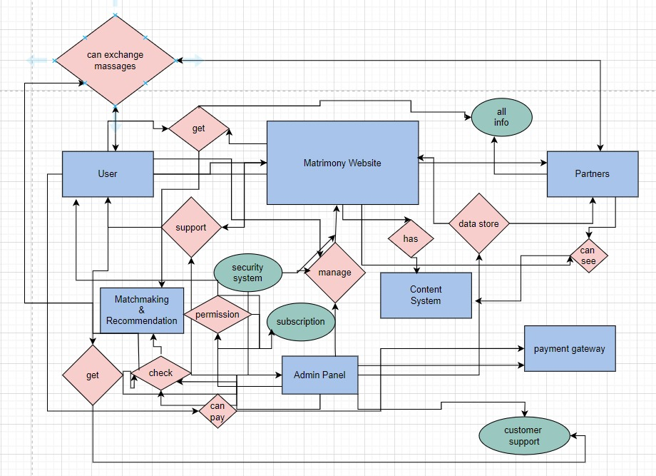

**6.2 Use Case Diagram**

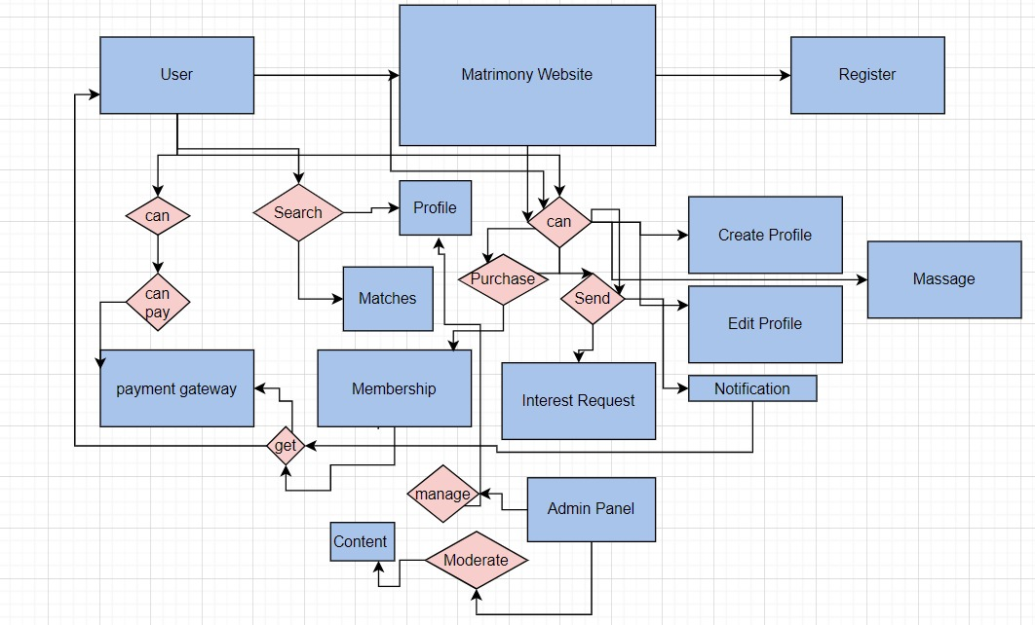

**7. System Evolution**

**7.1 Assumptions**

Users have access to modern browsers and internet connectivity.Payment gateways remain compliant with regional regulations.The system uses cloud-based hosting for scalability.

**7.2 Anticipated Changes**

Addition of mobile apps within 12 months.

Integration of AI-based matchmaking algorithms in future versions.

Support for video chat features based on user demand.

Expansion to international markets, requiring multi-language support.

**8. Appendices**

**8.1 Hardware Requirements**

Minimum Configuration: Cloud server with 4 vCPUs, 8GB RAM, 100GB SSD.

Optimal Configuration: 8 vCPUs, 16GB RAM, 500GB SSD with auto-scaling.

**8.2 Database Description**

**Tables:**

1. Users: Stores user ID, email, password , and registration date.
2. Profiles: Stores user details like age, religion, caste etc. and preferences.
3. Messages: Stores sender ID, receiver ID, message content, and timestamp.
4. Transactions: Stores payment ID, user ID, amount, and status.

**Relationships:** One-to-one between Users and Profiles; one-to-many between Users and Messages.

**9. Index**

1. Alphabetical Index: Admin, Match, Premium Membership, Profile, User.
2. Diagram Index: Data Flow Diagram (Section 6.1), Use Case Diagram (Section 6.2).
3. Function Index: Register, Search Matches, Send Message, Verify Profile.

**Requirements Validation**

**Validation Checks**

1. Validity: Ensures features like search, messaging meet user needs via stakeholder interviews.
2. Consistency: No conflicting requirements like privacy settings align with communication features.
3. Completeness: Includes all user and admin functions, verified through prototyping.
4. Realism: Feasible within a 6-month development timeline and $50,000 budget.
5. Verifiability: Test cases defined like “Search returns 50 matches in <1 second”.

**Validation Techniques**

1. Requirements Reviews: Conducted with stakeholders to identify errors.
2. Prototyping: A mockup of the search and profile pages will be shown to users.
3. Test Case Generation: Tests for registration, search, and payment processes to ensure implementability